OOP Assignment NO.2

Message APP Server Client

**Submitted by:** Muhammad Reyan(SP24-BSE-080)

Abis Raza Haider(SP24-BSE-145)

**Submitted to:** DR. Shahid Bhatti

**Welcome to our Message App:**

**Here is the Main Menu of our App**

**Where you can use different functions of that App:**

* Start Chat
* Display Messages
* Delete Messages
* Sort Messages
* 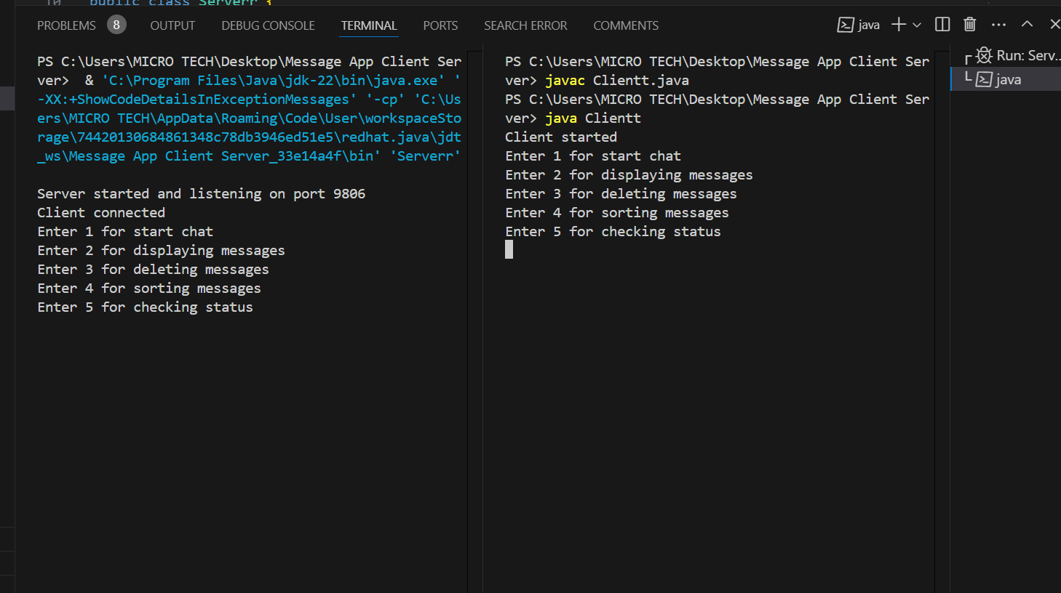Check status of the Messages

* **Now if we press 1:**

The connection between Server and Client will establish.

And our Chat function will start and starts sending messages to each other between server and client.

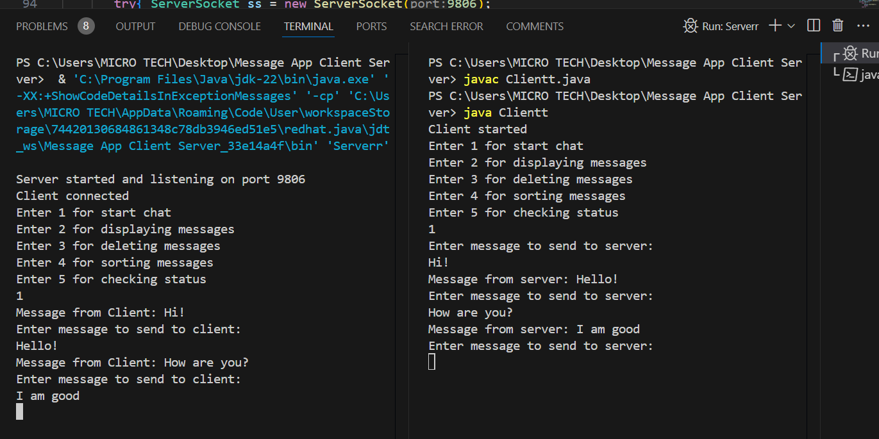

Now as you can see the chat between server and client has started. They are sending messages to each other.

* **If we want to exit from chatting:**

We will send (bye) message to each other.

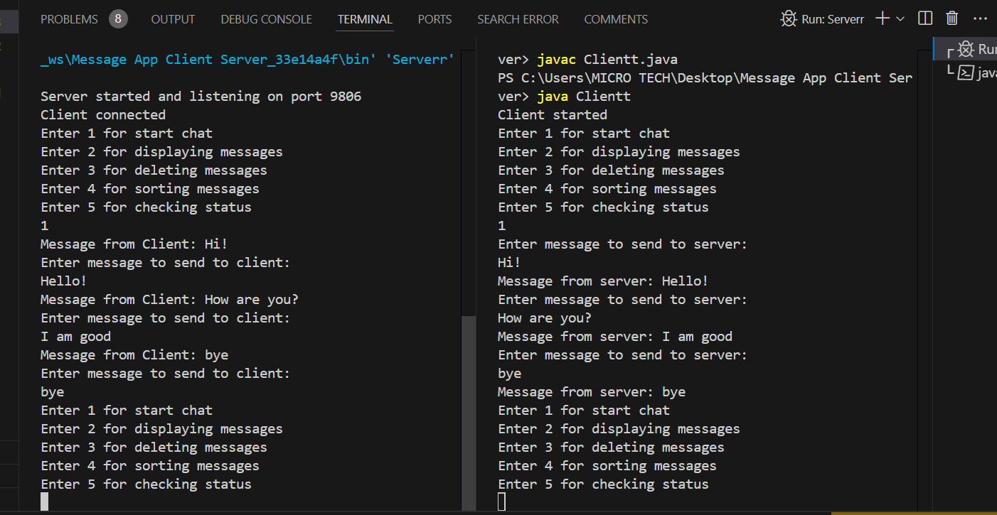

By sending bye message to each other connection is closed, and program controls again goes to Main menu of the App.

* **If we press 2 The Display method will call:**

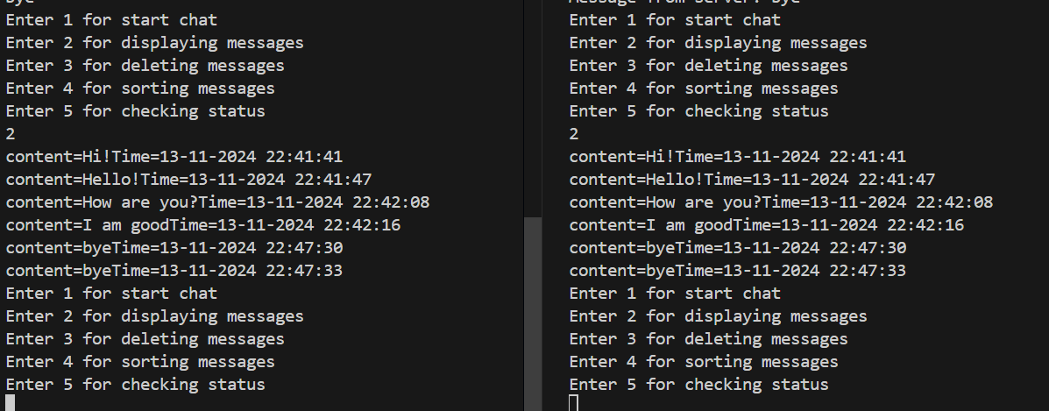

As you can see our messages are displayed according to time and content by pressing 2 and then again program controls go to Main menu.

* **If we press 3 Delete function will call:**

Then the program will ask us whether we want to delete a specific message or want to delete the entire chat.

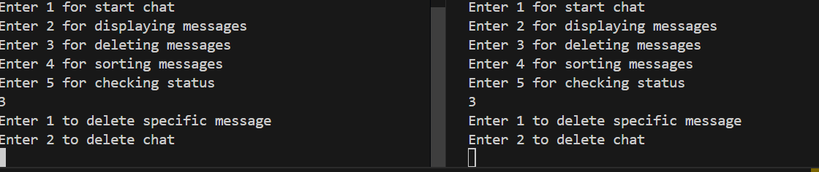

* **Then by pressing 1:**

The program will ask for a certain index for which we want to delete message.

By passing that index the message at that index will be deleted.

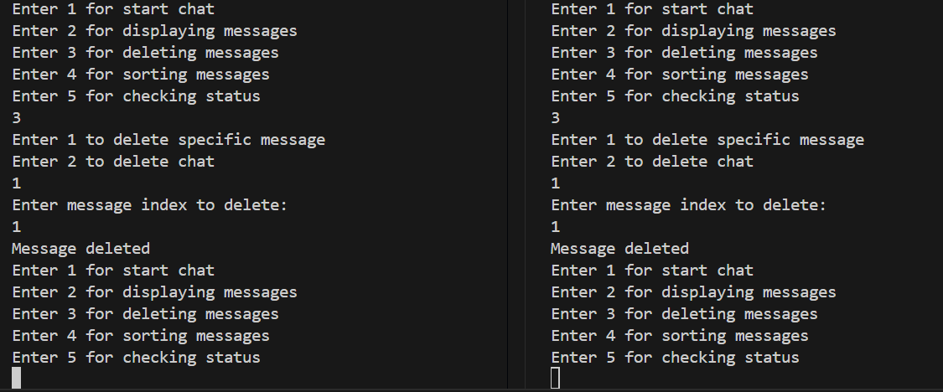

* Now if we display the message will have been deleted:

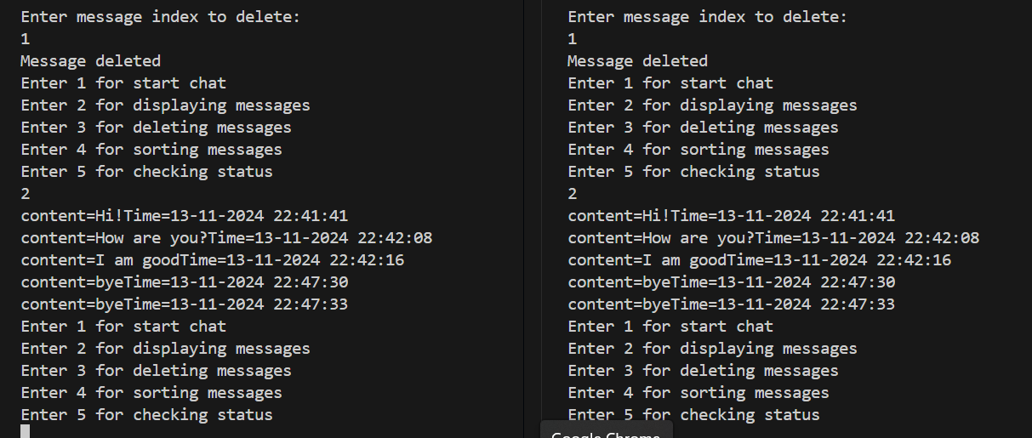

* If we press 2 the entire chat will be deleted.

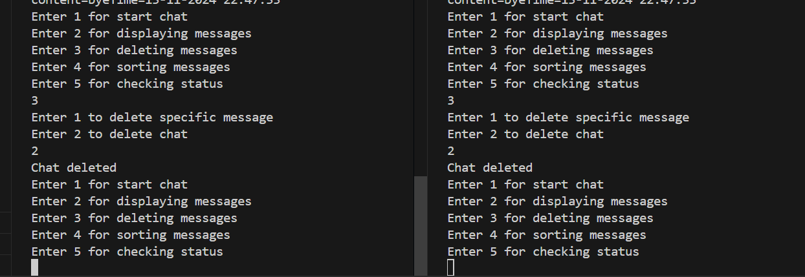

* Now the display of the message chat has been removed.

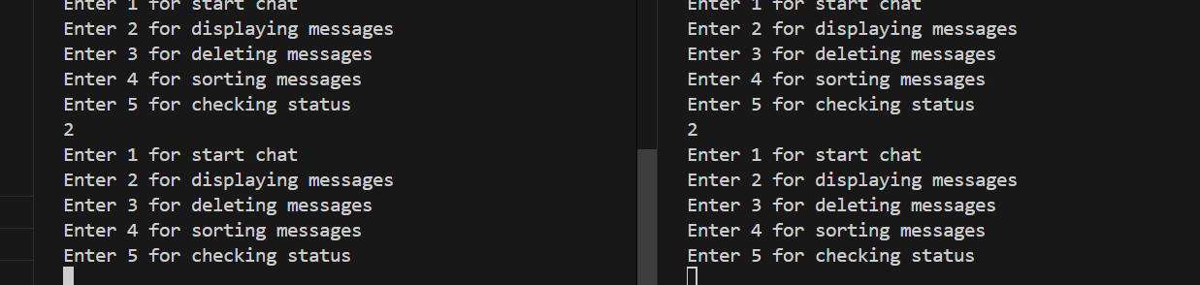

There is no message to display.

* If we press 4 the messages will be sorted in accordance to their time.

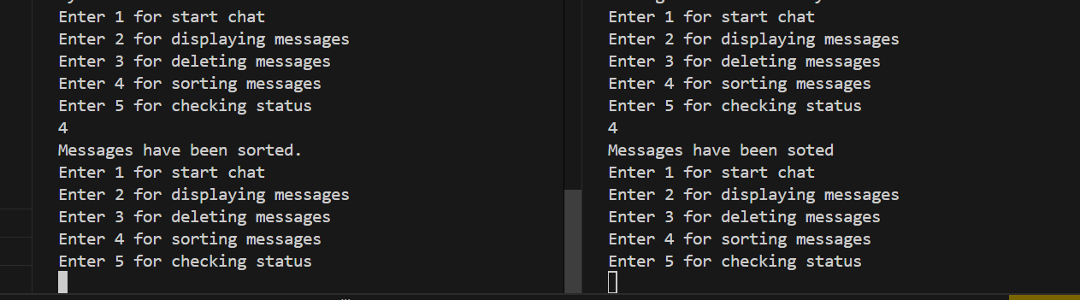

The messages have been sorted and displayed in time accordance.

* Now if we press 5 the messages status has been updated that all are seen because we display messages multiple times.

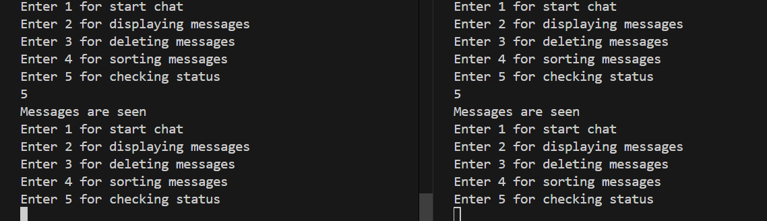

**That’s it our program has been terminated all functions worked.**

**Thank you so much!**